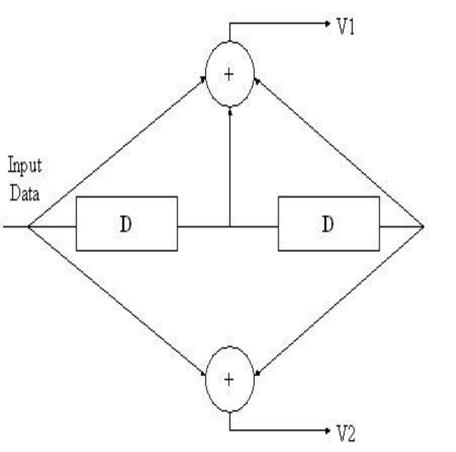
Fig1:-1/2 Convolutional Encoder.
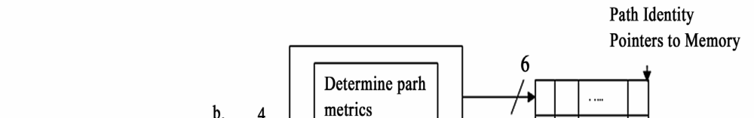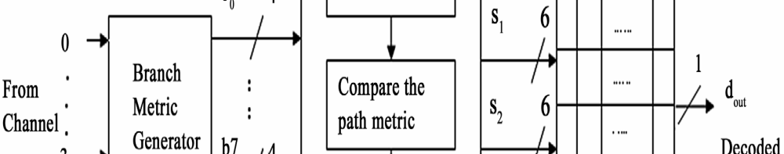
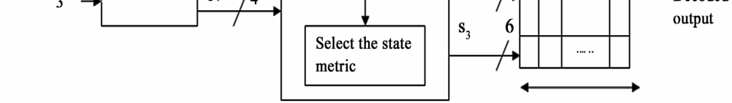
Fig2:-Architecture of parallel VD.

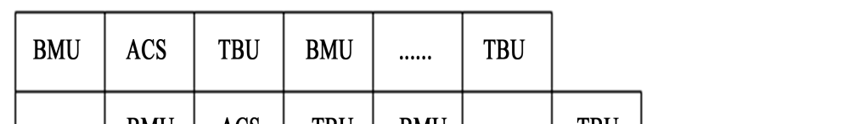
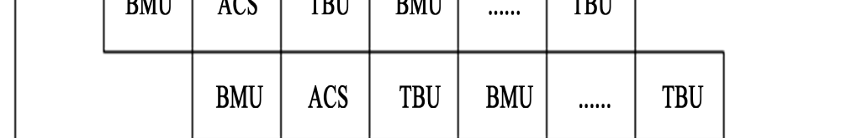
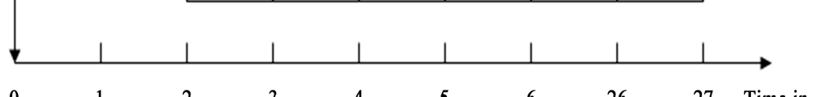
Fig3:-Parallel and pipelined execution of Viterbi Decoder.

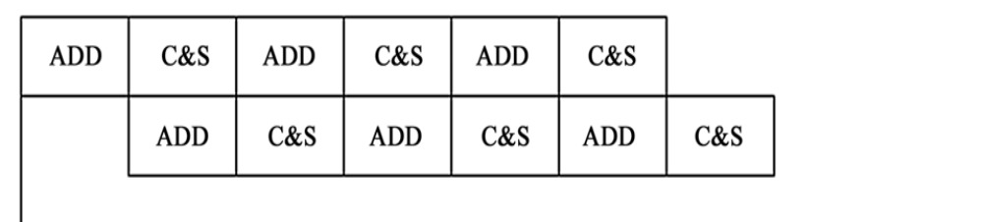
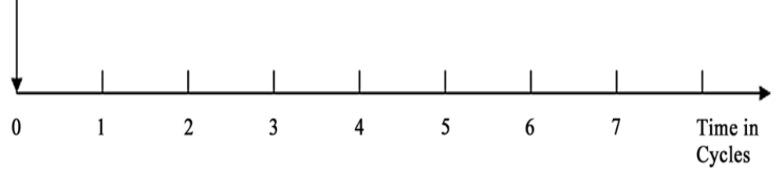
Fig4:-Deep pipelined execution of ACS.

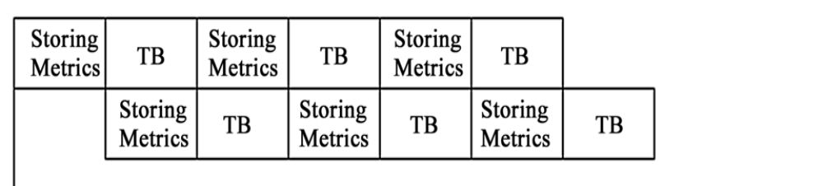
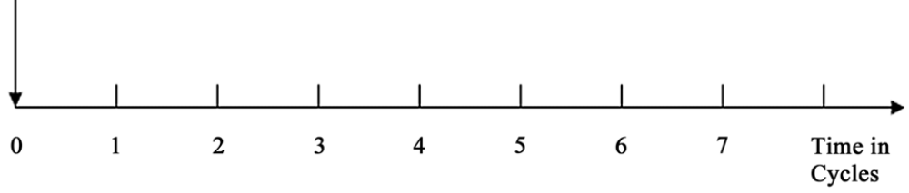
Fig5:-Deep pipelined execution of traceback unit.

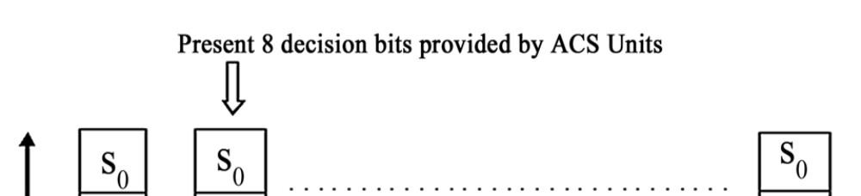

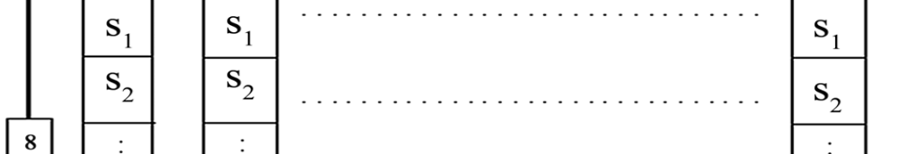
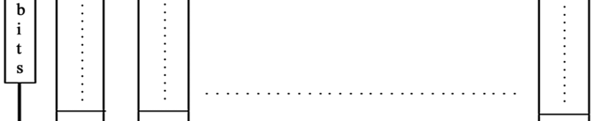
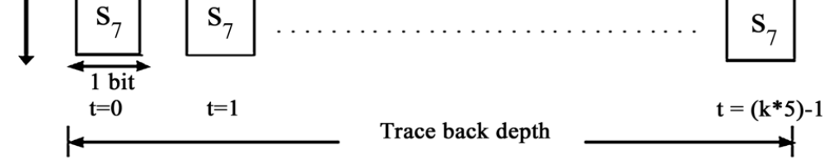
Figure6:-Selective update scheme for parallel VD

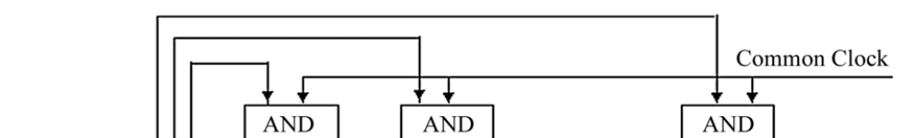

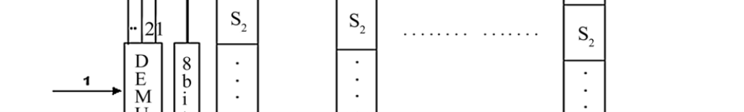

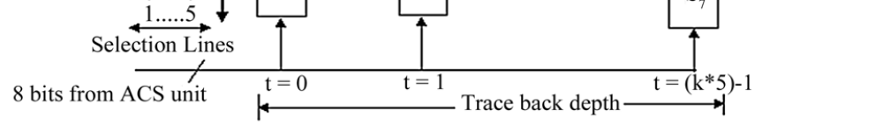
Fig7:-Survivor path storage for selective update for toggle filtering.




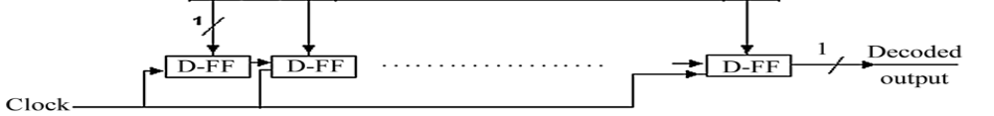
Fig8:-Proposed toggle filtering for traceback block diagram.

